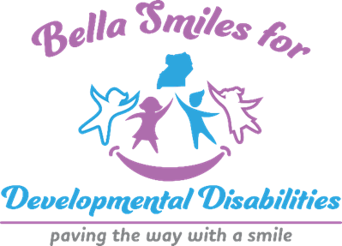

2025 Annual Impact Report

🔷 Mission: Empowering children and families with Intellectual Developmental Disabilities to access resources they need to live a more inclusive life.

🔹 2025 Accomplishments
- 🤝 Attended 10+ community events, building partnerships and raising awareness.
- 🎉 Hosted Annual Anniversary Celebration with 100+ attendees.
- 🎯 Inclusive Plays for Autism and Rett Syndrome Awareness reached 130+ families.
- 📘 Project "Guide to Good Hygiene During Menstrual Periods" for girls with IDD.

💰 Financial Overview
Category | Amount
Revenue | $23,000
Expenditures | $25,000
Sources: Donations, vending, and grants.

🕮 Goals for 2026
- Launch Specialized Day Center for children with IDD.
- Expand awareness campaigns on social media.
- Increase community outreach and engagement.
- Expand volunteer/Internship opportunities.

💙 Our Commitment: Dedicated to dignity, inclusion, and culturally grounded care. Every child and family deserves to be seen, supported, and empowered. For more information or to support our mission, visit: bellasmilesfordd.org call us (253)213-0065

